Award Tables

Geoff Anderson G3NPA and Aki Yoshida JA1NLX

1.0 GENERAL

Logger32 contains a comprehensive set of tables to display the statistics from the current logbook. Versions of Logger32, up to and including 2.3.0, have considered all entries to be QSOs and therefore included these into the awards table statistics. From version 2.4.0 onwards, a feature has been added to support incomplete QSOs (or heard, not worked QSOs). Simply put an '=' at the end of the call, i.e., G3NPA= will appear as a QSO in the Logbook, but any data recorded will not show in any of the Stats.

Note: If you try to QSL a recorded callsign which contains the "=" character, Logger32 will advise you of the error:

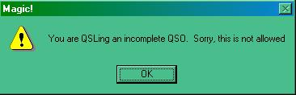

AT_1

W2RU - Bud Hippisley says-

"The uses for this feature are numerous, and limited only by your imagination. For instance, if you were accustomed to putting your CQs in your paper log (say you wanted a total record of when you were on the air, in anticipation of possible TVI complaints), you can now do that in Logger32 without it appearing as a QSO simply by entering 'CQ='.
Similarly, an informational log entry of WWV sunspot numbers no longer need show up as a spurious USA QSO; simply enter 'WWV=' and the data you wish to record."

Also see the topic Logbook Informational Entries.

From version 3.19.0 a new system of award tracking was introduced to supplement the awards tables as a result of changes made to the ADIF specification. For more details on this particular aspect please refer to the topic Award Tracking.

The awards tables can be accessed through the Logger32 Main menu Awards menu option.

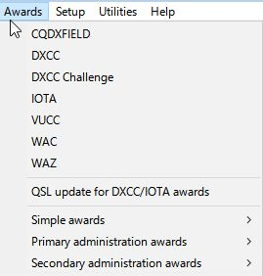

AT_2

The information available from each option is of a similar format so only one table is described here.

Awards are divided into three types namely

  - Simple;
  - Primary Administration; and,
  - Secondary Administration.

Primary and Secondary awards rely on data stored in the Primary (STATE) and Secondary (CNTY) ADIF fields.

Simple awards rely on data stored in one of the USER_X fields except for GridSquares, WPX and 10-10 award tables which use their own ADIF fields.

All awards tables show results for all bands but the 10-10 table need a special mention. Although the 10-10 awards table shows all bands, Only contacts made on 10M are valid and therefore only this column will be filled even if there are some records of 10-10 numbers against QSOs NOT on 10M in the logbook.

2.0 THE GENERAL AWARDS WINDOW

A typical Award Table is shown below. The data is shown on a per band basis as well as giving totals. Each band/country (or whatever) slot can show a (W)orked or (C)onfirmed flag. For some specific awards a credit (S)ubmitted or a credit (G)ranted flag can be shown. (An example of a “G” flag does not appear in the example below)

Selection of what is displayed can be refined further by the appropriate selection of the Mode, Operator and QSL type as desired. What is available here is dependent on your own log and general set up.

The Stats reflected in this chart can be for the “Complete Logbook” or depicted by Calendar Year. User selection is by pulldown menu in the 5th pane. See the Worked/Confirmed window section for additional details

It is also possible in some tables to sort by column. Like all tables in Logger32, if any column header is in Red (as is PFX in AT_3 above), then the option exists for the user to change the sort order to another indexed column (in the case of the DXCC Awards, the user can also sort by Country or CQZ). Simply click on the column title to sort.

The band order (high to low, or low to high) is dependent on the menu setting TOOLS | AWARDS SETUP | SHOW BAND COLUMNS IN REVERSE ORDER.

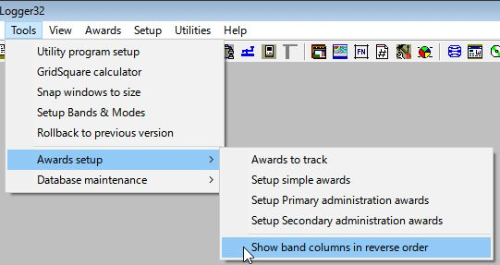

AT_2A

Award table for DXCC

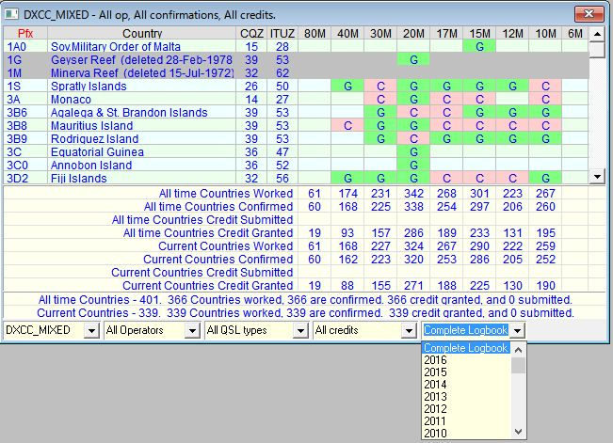

AT_3

Note: Annual stats option is available in CQDXFIELD, DXCC, DXCC Chalenge, VUCC and GRID squares Award table.

Award table for IOTA

Standard IOTA (All HF Bands) award counts QSOs only on HF Bands. If you want to see VHF/UHF award then check “VHF/UHF”.

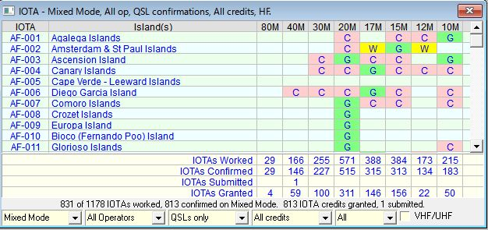

AT_3A

A left-click on any of the “W”, “C”, "S" or "G" flags will bring up a further window showing the details of those contacted for the selected square. Example:

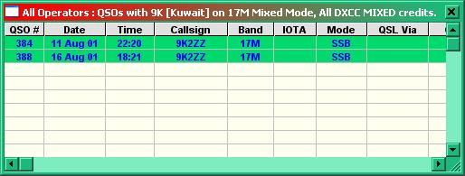

AT_4

Important Note: All awards except the DXCC Challenge will show data for those bands/modes that are marked with a “Y” in the Stats column of the Band/Mode table. In the table shown below a display of 6m and 10m activity for FM and SSTV is not required.

The DXCC Challenge will always display the 10 bands covered by the award irrespective of the Band/Mode table.

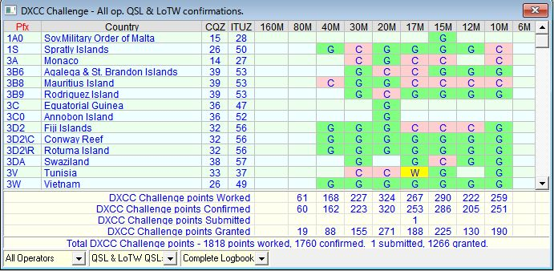

AT_5

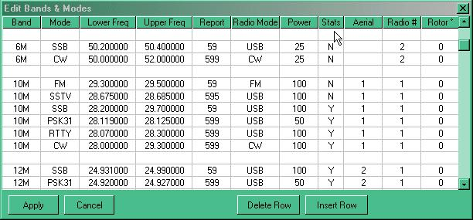

AT_6

For additional information, see the sections Logbook Page window and Previous QSOs window.

3.0 THE VERIFIED ENUMERATION

As far as Logger32 is concerned the “V” enumeration system that was introduced in earlier issues has now been totally removed and replaced with a much more comprehensive system. Refer to the Award Tracking topic for more detailed information.

4.0 PHONE/DIGITAL MODE SETUP

For details on how to setup Awards for Phone and Digital modes, see the section Phone/Digital Mode Setup in the Logbook Entry window.

5.0 PRINTING AWARDS TABLES

See the topic Printing Awards Tables.

6.0 FAQs

The most common question relating to the awards tables is:

Q: “My awards table does not show up my 20M contact with xx9xxx (some remote or rare callsign)”

A: There can be a number of reasons why this might be, so check:

  - Was the QSO entry logged under the “Operator” you anticipated?
  - If you are not using the “Mixed mode” display, have you selected the correct mode for the QSO in question?
  - If you have been editing directly in the logbook it is advisable to perform a “recalc”. See the Logger32 Main menu Tools | Database Maintenance | Recalculate statistics menu items.
  - Check the actual log entry. Is all the data shown correctly? Quite often the problem is one of the DXCC entity recognition from the prefix.
  - Is the particular band/mode combination shown as a “Y” in the Stats column of the BandMode table?
  - Are you looking at the correct logbook? As Logger32 will maintain as many logbooks as you desire – are you looking at the right one?

  - If using the digital mode option, have you got that mode included in the digital mode table?

Be aware that CQ Zone tables compiled from your logbook may result in erroneous statistical summaries unless you take pains to clarify the status of ambiguous entries. This problem is most apt to occur where CQ Zones split political or radio licensing boundaries.

For example: all states in the USA 4th call area are in CQ Zone 5 except Alabama, which is in Zone 4.

In the absence of additional detail when logging a contact, Logger32 treats all 4th area stations as being in Atlanta, Georgia, and accordingly assigns CQ Zone 05 to these log entries. Thus, a QSO with W4AP in Montgomery, Alabama will be logged (incorrectly) as Zone 05 until you provide more detailed information. Upon entering "AL" in the State field of your Logbook Entry window or the State column of your Logbook Page window, the Zone entry will change from "05" to "04" which is correct.

Note: If you later remove the State information from your log entry, the CQ Zone for your contact with W4AP will revert to the generic "05" for 4th call area stations.

Also note that Logger32 does not automatically use State information from a QRZ.com lookup.

7.0 AWARDS TABLE SETUP

7.1 General

Releases of Logger32 up to and including Version 2.8.1 were designed to be compatible with the Amateur Data Interchange Format (ADIF) specification version 1. Any logbook information which complied with this specification could be used with Logger32. The ADIF specification has now moved on and although quite a lot of the specification remains unchanged there are some significant alterations. In an attempt to maintain compatibility, Logger32 has now undergone a major change. For those that would like to study the revised ADIF specification a copy can be found on the ADIF web site.

The main changes to the specification have concentrated on the definition of the various fields, adding a large number but also changing the use of and/or deleting others.

Many countries (DXCC entities) are historically subdivided into smaller regions. And even these can be subdivided again. Take the USA where there are 48 contiguous states and in each state, numerous counties. Because there are so many variations, and not all of them geopolitical, it was very difficult to cover this in ADIF. It would have been impossible to cover all the variations unless you created a confusingly extra number of ADIF fields. With the new system of Primary Subdivisions and Secondary Subdivisions almost all variations can be covered in only two fields. These fields are still called "STATE" and CNTY but from now on the State field will cover all primary subdivisions and the CNTY field all secondary subdivisions.

The most significant change, as far as Logger32 is concerned, is the redefinition of the original STATE and CNTY fields. These are now defined as:

Enumeration function of Country Code - the code for the contacted station's Primary Administrative Subdivision, i.e., US State, JA Island, VE Province.

CNTY Enumeration function of STATE - the contacted station's Secondary Administrative Subdivision of contacted station, i.e., US county, JA Gun, in the specified format.

Some Primary Administrative subdivisions are also defined but no Secondary

This revised system now allows for the recording of award data in just two columns the primary (STATE) and Secondary (CNTY). For example:

AWARD | STATE | CNTY
 | (Primary Subdivision) | (Secondary Subdivision)
WAJA | 12 | for Chiba prefecture
JCC | 01 | 03 for Hokkaido Otaru
JCG | 10 | 004 for Tokyo Oshima
DOK | E | 23 for Hamburg Trave
WAS | CA | for California
US Counties | CA | Alpine for Alpine County CA

It can be seen in the last entry in the table above that the handling of the original State and County records is much the same but the system has been expanded to accommodate other information.

The new system allows for the generation of ones own awards tables to a limited extent. Based on the primary data there is no reason why a specific/personal secondary database could not be formed and hence listed in an “award” or stats table. DOK, JCC and JCG awards will fall into this category.

Although Logger32 will include DOK, JCC and JCG data and awards tables, there are hundreds more awards that will NOT be included. It will be for the individual to add/subtract what they require in the way of awards data and for them to make up the appropriate databases accordingly. While awards based on secondary administration information can be formulated, it is not generally possible in the case of primary administrations. For example, it is not possible to generate an award for WAE or CCC where a large number (but not all) of DXCC entities are involved. The maximum number of DXCC entities that Logger32 will accept, at this time, for a primary administration award is five.

The first thing to fully understand is that the fields that were called State and Cnty will now hold primary and secondary subdivisions data. You will have to ask those who wrote the ADIF specification as to why they didn’t actually change the name of these fields at the same time so as to make it less confusing. Logger32 is simply following the specification.

If you have set up your Logbook Entry window to accept a US State and County, then it is recommended that you change the title of these input panes to reflect their new status as Primary Admin and Secondary Admin and the same applies to the column titles in the log AND the previous QSO tables.

In addition to the change of use of the STATE and CNTY fields, the original DOK, JCC and JCG fields have become redundant. These have been renamed as USER1 to 3 respectively and are used as data input for “simple” awards (discussed later).

Also the SubMode and VE_Prov fields are not used in ADIF ver 2.

In versions of Logger from 2.9 onwards, the Submode field, a non-index field (you cannot sort on it), has been reused as the new K_INDEX field and the VE_Prov field, an indexed field (you can sort on it), has been reused as the new SFI field.

Notes

  - The original data (SUBMODE and VE_PROV) has not been cleared from the logbook(s). If you intend to use these new fields, you should check and edit out any data that is left from earlier use of the fields; and,
  - The fields are now a maximum of three digits in length.

Finally the AGE field has been replaced by DISTANCE (being of far more practical use).

DISTANCE (in Km) is automatically logged the same way as SFI, A_INDEX and K_index. This is a non-index field (you cannot sort by DISTANCE).

In summary, the following ADIF fields have been renamed/reused as follows:

Original field name New field name

State State (Primary Admin Subdivision)
Cnty Cnty (Secondary Admin Subdivision)
DOK, JCC, JCG User1,2 and 3
VE_Prov SFI
Submode K_Index
Age Distance
New field (added) A_Index

7.2 Databases

Two new databases are provided called PrimaryAdmin32.xxx and Secondary Admin32.xxx where xxx = ISD, ISF, ISM and ISL. As the names imply, the PrimaryAdmin32 database contains all the information about primary subdivisions (as listed in the ADIF specification) and the secondaryAdmin32 database holds the secondary information. Typically, these will contain the US counties, the JCC, JCG and DOK information. If the user adds any further secondary data, then it will be stored in this set of files.

Full editing facilities of both these databases are included with the new software.

In line with the general changes, the County32 database is no longer used and can be deleted. [BUT DO NOT DELETE ANYTHING ELSE]

7.3 Editing the New Databases

General words of Caution

As a general precaution, you are strongly advised to make a backup copy of any database that you are going to edit. You are entering dangerous territory… and you might well need the ability to backtrack.

The basic primary admin. data is held in the four files named PrimaryAdmin32.ISD, .ISF, .ISM, and .ISL . The secondary Admin. data is contained in the four files named SecondaryAdmin32.ISD, .ISF, .ISM, .ISL and all eight are located in the default Logger32 directory.

It should be appreciated from an early stage that Logger32 will only provide the backbone or basic primary and secondary subdivision databases. Any changes that you make or add to your personal copies of these databases will be destroyed on the loading of a new set of (say) Logger32 databases or set from anyone else – UNLESS definite precautions are taken.

It is possible to save each individual award and or country information (both primary and secondary) into CSV files and if you like to construct your own databases for awards this method of saving the files is HIGHLY recommended. It is then relatively easy to re-load your personal databases when required.

7.4 Primary Administration Data

To edit the contents of a particular Countries primary data, use the Logger32 Main menu Tools | Database maintenance | Primary administration maintenance.

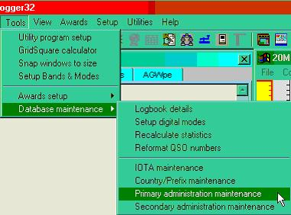

AT_8

followed by the selection of the Country (or Administration) of interest

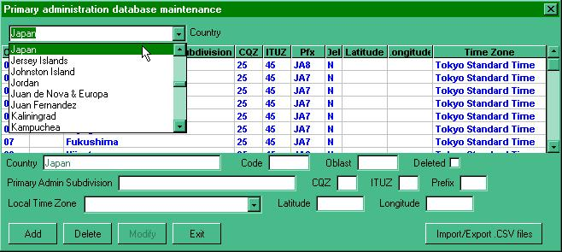

AT_9

to open the appropriate edit page.

To edit a single entry, scroll to the required position in the list and left-click on the line required. The existing data for that line will now appear in the panes below the main list ready for editing. All panes can be edited except for the County. When set to the new requirements, select the <Modify> button.

If it is a new entry that is required, scroll to the bottom of the viewing list and click on the blank line and enter the new data. On completion, select the <Add> button to save the entry into the database. Note – the display will jump back to a point near the top of the list, so to check your new entry you will need to scroll down again.

If there are a large number of changes to be made then the facility to export the data to a .CSV file is available. Simply use the “Import/Export.CSV files” button located to the bottom right of the database maintenance window.

Make sure you are going to export the required county data (selected in the upper pane) and use the <Export> button as shown below. There will follow a familiar method of section of file name to use for the new file and this will be followed by an announcement of the number of records exported.

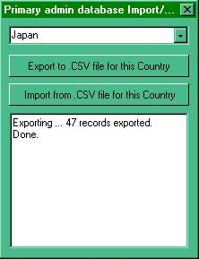

AT_10

The CSV file produced is then available for import into Excel for further work. The same <Import/Export> button is used when re-loading the database.

A Note of Caution When reloading revised data you MUST ensure that the correct country is showing in the various indicator panes. If the wrong country is showing you will overlay data to the incorrect area in the database.

7.5 Secondary Administration Data

These databases are used to assemble the required data for some of the awards tables. It is here that it will be possible for the user to develop background information for individual award tables

From the Logger32 Main menu, select the Tools | Database maintenance | secondary administration maintenance menu items and then the required Award (JCC in this example) from the uppermost selection panel.

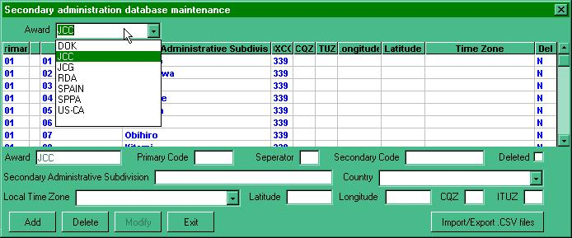

AT_11
to obtain the edit window shown above. The editing and import/export are very similar to that described above.

A word of caution here when using Excel to generate the database. If the DXCC and primary and/or secondary data is numeric and has the need for leading zeros, then the appropriate cells should be formatted in Excel BEFORE exporting the data in CSV format. Also it will be noticeable on import to Excel as the leading zeros will not show until the columns are formatted.

To format the particular columns in Excel, click on the column header to highlight the column required and RIGHT-click the mouse and select “format cells”. Select “custom” and make the Type read 00 (for two digits) or 000 (for three digits) and select the <OK> button. Leading zeros will now show and will be recorded in the output .CSV file.

8.0 AWARDS

Logger32 now supports three types of awards:

  - Based on Primary database (Primary Subdivision awards) example: WAS;
  - Based on a Secondary database (Secondary subdivision awards) example: JCC, JCG, DOK; and.
  - Awards having no databases or reference lists as such. The user simply enters the data and the list continues to grow. (Simple awards). example: Gridsquare, WPX.

In order to construct and use an award table it is necessary to go though a number of steps – depending on the type of award. In the main the user will construct secondary or simple awards.

Note the terms “secondary” and “simple” here refer to the way Logger32 handles the tables, and no reference to the quality or otherwise of the award itself is implied

8.1 Primary Awards

The major primary awards use ONLY information from the primary administrations database. The WAS (Worked all States) award is a good example as it uses data from three DXCC entities namely the USA, Alaska and Hawaii. In order to set up this award (assuming that the primary administration database is present and complete), all that is required is to define the Award name and which administrations to use.

On the Logger32 Main menu, select the Tools | Awards setup | Setup primary administration awards menu items to open the Primary administration award setup dialog box as shown in AT_13 below. Here it is possible to define the award name and the DXCC countries that count towards the award.

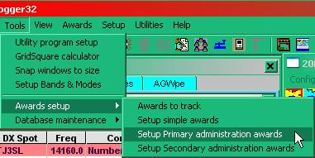

AT_12

Note that award No.1 is already used (WAS). If you are preparing a new award, then select an award number that has no associated name. In any event, be VERY careful not to overwrite existing award data

When selecting a country, use the pull-down list as this will then only present those countries where data is present in the database.

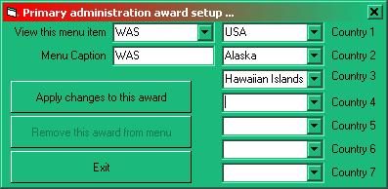

AT_13

Once you have made your changes as required, select the <Apply changes to this award> button and the award table will become available in the primary admin. award menu listing as follows:

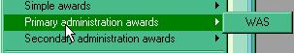

AT_14

8.2 Secondary Awards

This is the area that is most likely to attract user attention and where awards based on more specific or perhaps personal preference data can be constructed. The award however MUST be associated with a primary administration database. For example – DOK, JCC and JCG are obvious selections but lists like UK lighthouses or something relevant to the users own country could also be included.

In order to make this work it is necessary to complete the following stages

  - Ensure primary data present. It is important to realize that not ALL DXCC entities have primary data entered for their country;
  - Construct a new secondary data list. This would be the list of your choice;
  - Load new secondary data list into the Secondary database itself; and,
  - Make the new award available in the secondary admin. awards menu.

A description designed to give a better appreciation is given below entitled “Setting up for an award –n example.”

8.3 Simple Awards

These awards will have no reference list as such. The data will be collected from one of three “User x” fields (where x=1, 2 or 3) and the data will simply continue to grow as new entries are made –n a similar manner to the WPX award listings. The operator can collect almost anything they want but some obvious selections might be Special DOKs, Castles or Summits on the air, lighthouse references, etc. The User_x fields are the re-named DOK, JCC and JCG fields so it is possible that there might be data contained somewhere within their columns. The user will have to edit these entries as appropriate.

Note: Starting with Logger32 version 3.50 the user_x fields are enlarged to 50 characters maximum. Like most of the ADIF fields, the User x fields may be utilized within the Logbook Entry window if desired.

In order to make the simple award table available in the awards selection menu and to define which fields are to be used for which award, select the Logger32 Main menu Tools | Awards setup | Setup simple awards menu items from the main menu and complete – as appropriate.

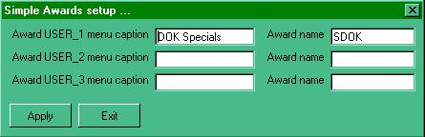

AT_15

The left hand entries will appear in the simple awards menu

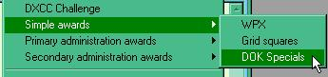

AT_16

while the entries into the right hand entry panes will appear above the award table itself.

9.0 Entering award data via the Logbook Entry window

When entering award data into the log, simply add the primary (STATE) and secondary (CNTY) data to the Logbook Entry window (as one would have done for US State and County) and select the <Enter> key.

Note that in the example given below, the P.Admin and S.Admin input panes are actually the STATE and CNTY fields renamed in the user input setup options

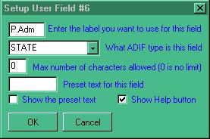

AT_17

If this data is not known then left-click of either the primary or secondary <?> buttons (as seen below)

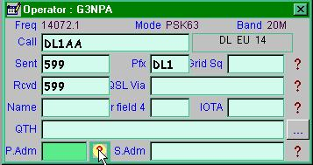

AT_18

and select the primary and secondary subdivisions as required using the right mouse button and the data will update in the Logbook Entry window.

Logger displays further information at the bottom of the window

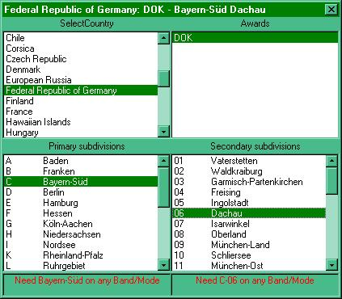

AT_19

10.0 Entering/Editing award data via the Logbook Page window

It is not possible to edit directly into the primary/secondary columns of the logbook. If this is required, then right click on the secondary admin column (was CNTY) to bring up the option menu. Select “Edit Admin Subdivision info” and Logger32 will pause and then present the user with the complete set of primary and secondary selections available.

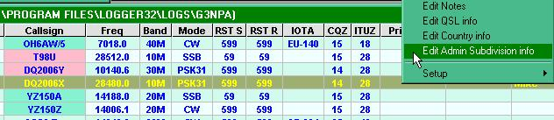

AT_20

In the example shown above, where the QSO in question was with a German station, then Logger32 will display the appropriate table thus:

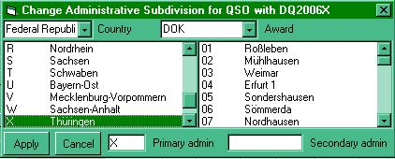

AT_21

Simply select the appropriate award (for the country), highlight the primary and secondary data (or type in the code into the appropriate panes), then select the <Apply> button to transfer the data to the log.

On occasions the award pane may not fill automatically. This is either because there are more than one award set up using the primary data (an example would be Japan and the JCC/JCG awards) and Logger32 cannot determine which to use or no primary data has been set up for the particular country.

Note: If the primary code does not exist, then Logger32 will generate an error message. If the code being entered is valid, then check the primary and secondary databases for the country and/or award.

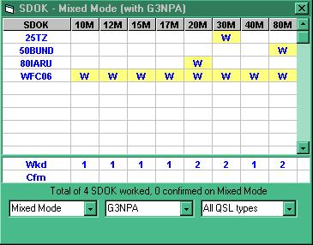

AT_22

11.0 SETTING UP AN AWARD - AN EXAMPLE

Along with the new primary and secondary administration databases comes the option to construct award tables that are not otherwise provided. Awards can be based on either primary administration information or a combination of primary and secondary information. The “walk through” example given below will be based on secondary information. Please note that the construction of awards tables based solely on primary administration data is a very similar to that described below except they do not require any action at 11.2 step 2.

The example assumes the following:

  - that it is an award based on England;
  - that England is divided into two primary sections – North with the reference AA and South with the reference BB; and,
  - that the North has 3 subdivisions called demo only, demo2 and demo3, with the reference numbers 01, 02 and 03 respectively, while the South has 2 subdivisions called demo 4 and demo 5 with references of 01 and 02 – thus giving a total of 5 subdivisions AA01, AA02, AA03, BB01 and BB02.

11.1 Step 1 – Create the primary database

Open the Primary admin. database maintenance window (as described in the described in the Editing the New Databases section) and using the pull-down tab for the “Country”, select England. In this particular case it will present a completely clear edit form. [Note –his might not always be the case]

Enter the two primary divisions [AA and AB] manually using the entry/edit panes below the blank data list. When each entry is complete, “Add” the data.

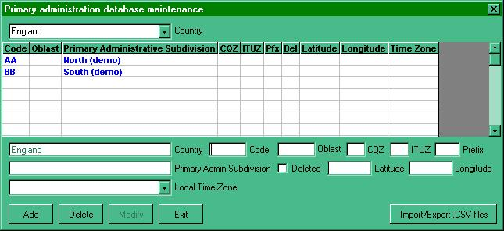

AT_23

If you wish to retain the data in a CSV file for later addition or modification using Excel then use the <Import /Export CSV files> button.

11.2 Step 2 – Create the secondary (award) database

Open the secondary admin. database maintenance window as described above and using the pull-down tab for the “Award”, select the blank area at the base of the list. This will present a completely clear edit form.

Enter the name you wish to use for the award in the topmost pane. Note that whatever you have placed here will now appear in the “award” pane just below the blank data list.

Enter the first record manually using the entry/edit panes below the blank data list. The Primary, Secondary codes, the Admin. subdivision (name) and the Country are required. Note that the pane called separator allows for codes such as AA-01. If left blank then the accepted code will become AA01. When complete, select the <Add> button.

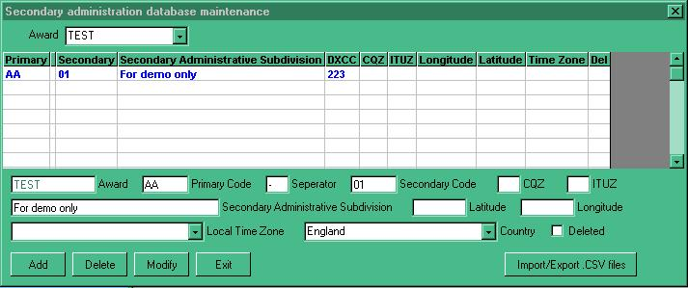

AT_24

Export the CSV file, giving it a name and then import the resulting file to Excel and this will set up the spreadsheet ready for the addition of all the remaining data. (Note below that the numeric in the secondary column is without a leading zero. (See A Note of Caution above).

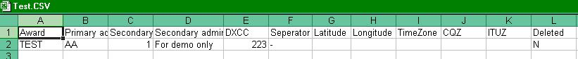

AT_25

Add the required data to the spreadsheet. Make sure that numeric columns are formatted as required and re-save.

Reload the new database into Logger32 using the import facility from the secondary admin. database edit window

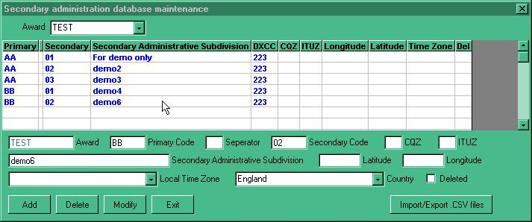

AT_26

If the award subdivisions spread across different DXCC entities, then simply make sure that the appropriate DXCC code is entered in the column for the area concerned and that there is a valid entry in the associated countries primary database. The example above shows areas for England only. If you wish to see an example of a database covering multiple DXCC entities, then look at the secondary database for US counties.

11.3 Step 3 - make it all visible

Having made the database it is now necessary make the award available in the menu list.

From the Logger32 Main menu Tools | Awards setup | select Setup secondary administration awards menu items to open the window shown below:-

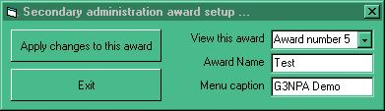

AT_27

select the first available blank “Award number” and enter:

The Award Name – This is the file name that you have given to the award, and

The Menu caption – The description you wish to display in the pull-down awards menu list and click on “Apply changes to this award”.

The award will now appear in the menu list as shown below.

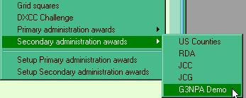

AT_28

to give the award table from the log (as shown below)

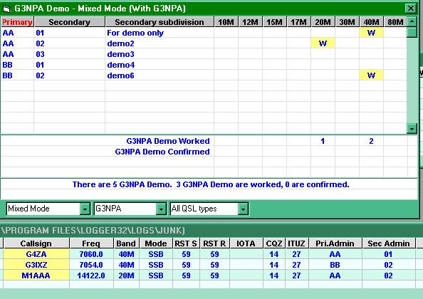

AT_29

